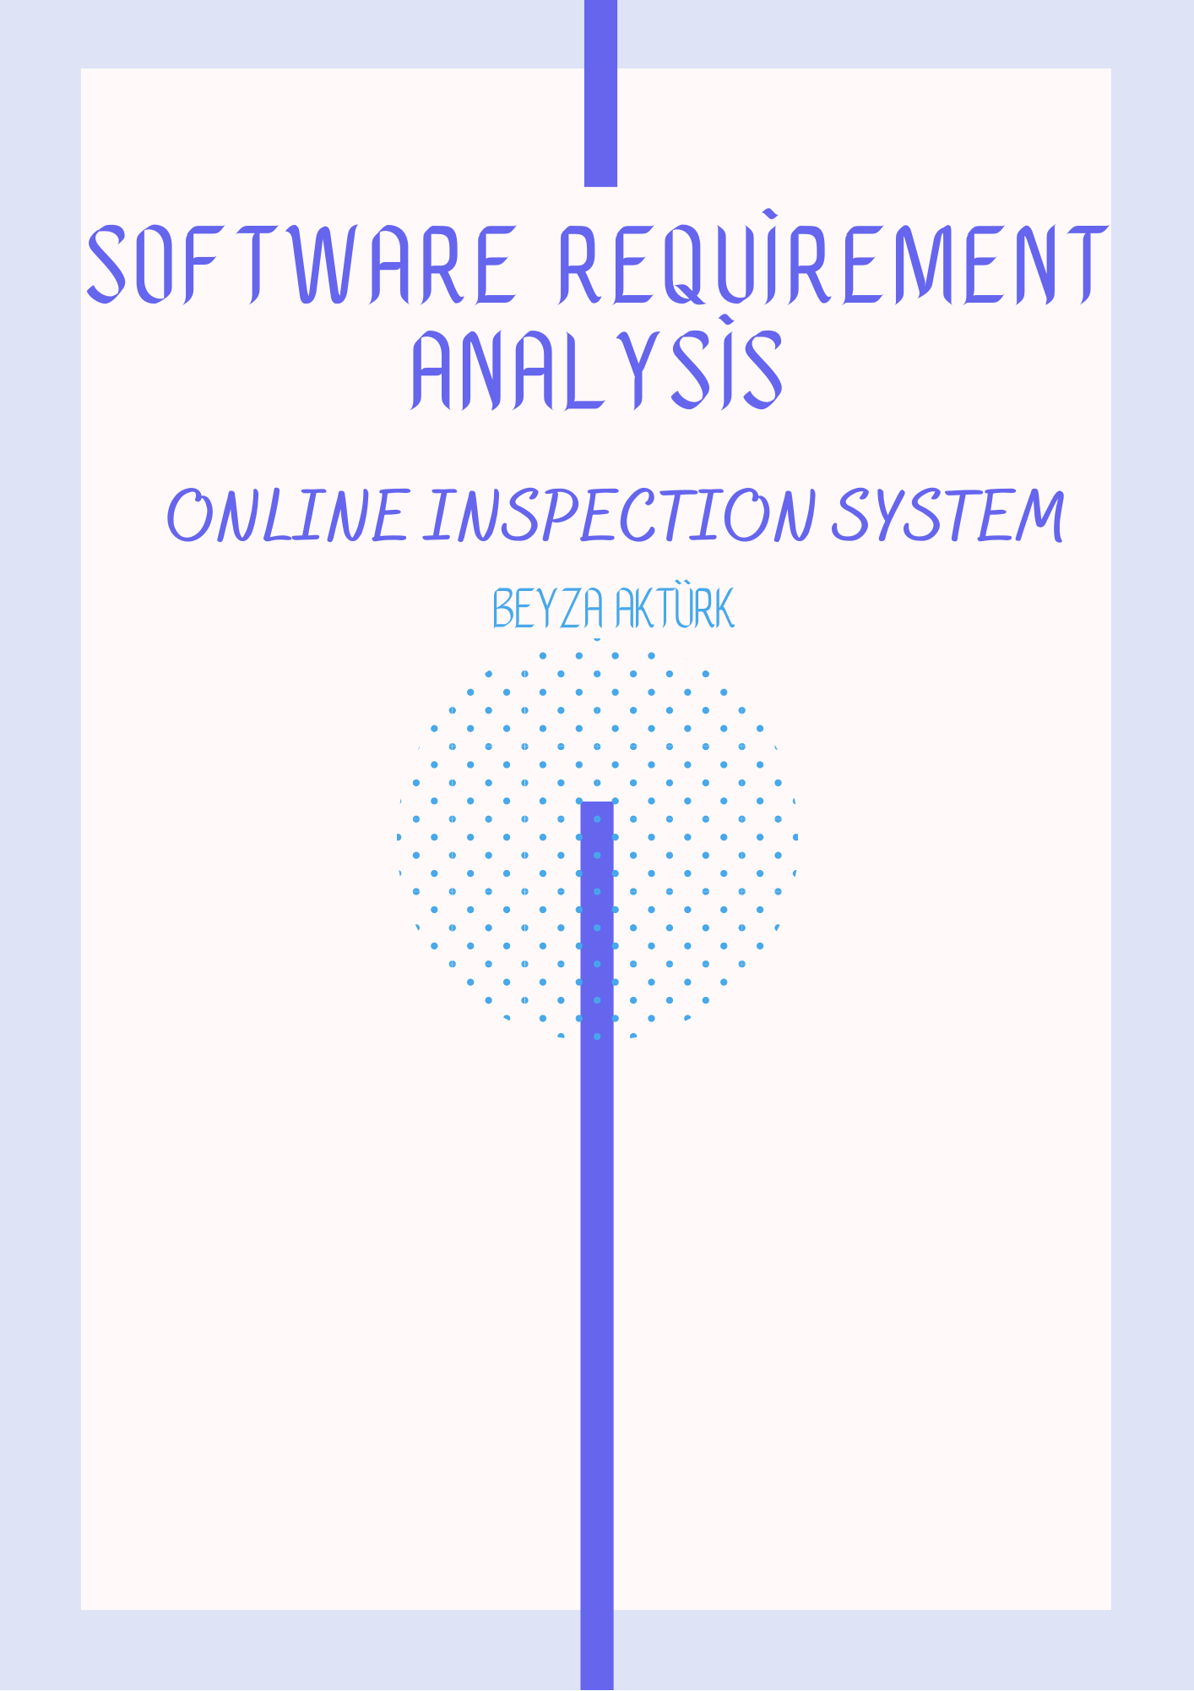

**1. Introduction**

**1.1 Purpose**

The system aims to determine the stages such as assay,X-ray, which can help the diagnosis of patients before they come to the doctors, and to make appointments so that the patient spends less time in the hospital.

**1.2 Scope**

The online examination allows the patient to spend less time in the hospital by setting up appointments and determining the stages such as assay,X-ray, which can help the diagnosis of the patients before they come to the doctors. An artificial intelligence uses this data as training data to predict disease by reading patient complaints, assays and doctor responses.

**1.3 Target Audience**

Patient

Doctors

Laboratory Staff

**2. General Definition**

## IPO(Input-Process-OutPut) Diyagramı

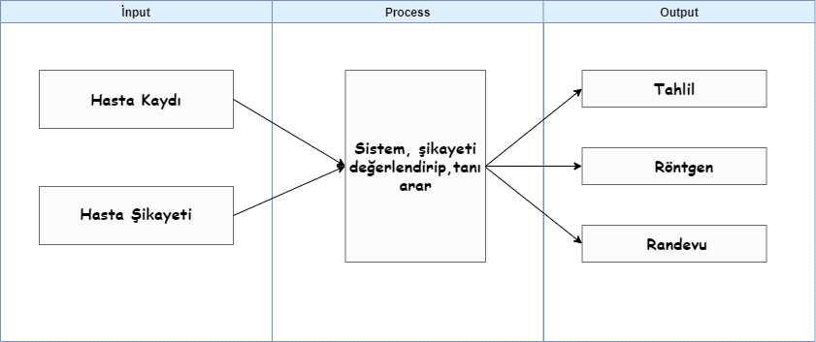

**2.1 Product Overview**

The system consists of a web application. The data is saved to the server. The server is backed up at regular intervals.The user must log in to the application with the user name and password. All transactions that the user performs after logging on are recorded with the date of the transaction. In practice, IP or day-to-hour restrictions can be made, and access to the system can be denied except for specified IPS or the specified day-time.Users can only view the screens within their authority and log in via sms. The user can choose the complaint and answer other questions that doctors often ask. The system-assigned analysis can create appointments by selecting the desired date,time and doctor for procedures such as X-rays.

# 3. External Interface Requirements

## **3.1 User Interfaces**

When the user runs the application, the user TC encounters a login screen asking for a password.

If you have not registered to the system before, you will see a screen showing that you need to click on the membership button.

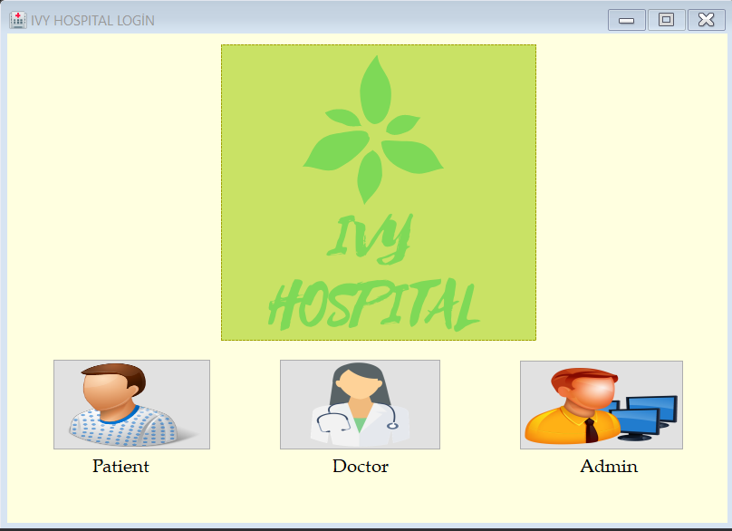

When you plug into the membership section,you will encounter screens asking for first-name,TC,serial number,province,County, phone and email information.Complete the membership by filling in and can log in to the system.

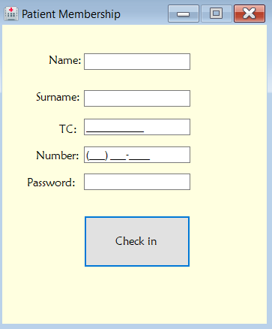

After logging into the system, the user encounters an erkran who must enter his / her complaint / discomfort.After making the selections, the label3 section (normally visibility will be off) writes the action that must be taken as a result of the choices it makes.You can create an automatic appointment accordingly.

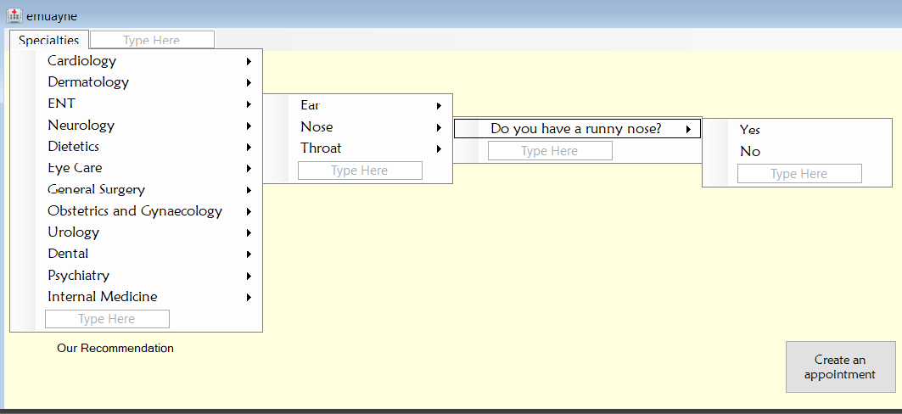

When the user arrives at the appointment screen,he / she will complete his / her appointment after filling out his / her Provincial,District,Hospital,doctor, date and time information.

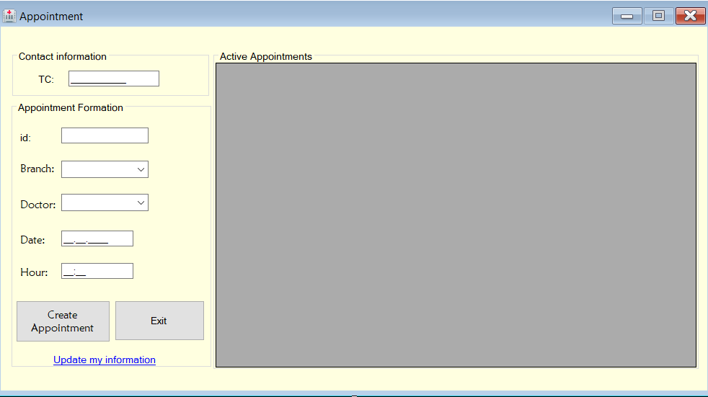

**3.2 Hardware Interface**

The printout of the reports will be available through the printer.

Barcode printing will be performed with barcode printers.

## **3.3 Software Interfaces**

It will talk to media devices via web service.

Application can be run with desktop shortcut or web browsers

### UNIFIED MODELING LANGUAGE

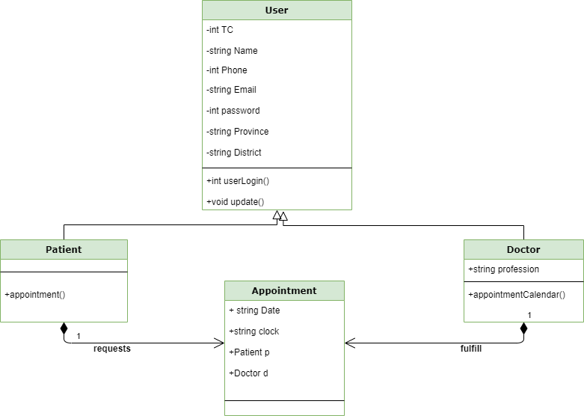

**USE CASE DIAGRAM**

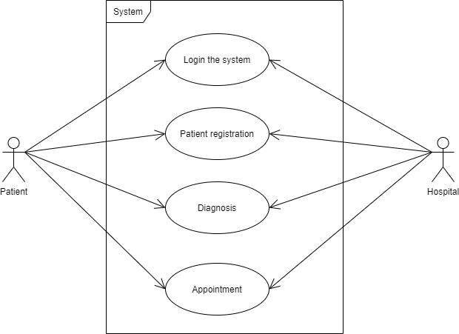

**4.Performance Requirements**

It should allow multiple users to enter requests at the same time.

There will be no longer than 5sec waits on crossings between screens.

**5.Security Requirements**

Users with screens used in Use case diagrams are restricted, and access to screens not associated with use case should be blocked.

Requests cannot be viewed by anyone other than a doctor, patient or System Administrator.